**ROUGH PROTOCOL for ITS MiSeq SAMPLE PREP**

Created by C. Kenkel, last edited by Sarah W. Davies on May 19, 2015, edited by Sarah W. Davies again on July 5, 2015, adapted for Boston University by Nicola G. Kriefall on April 11, 2018.

This protocol was developed to amplify single sequence products via the MiSeq platform in order to gauge within-sequence diversity of the ITS2 region. However, this protocol can be applied to any amplicon sequencing application. As long as you have obtained high molecular weight DNA, this protocol should work. It is important to start with a large template amount in order to include all the sequence diversity that exists. Cycle checking avoids over-amplification of products, which can result in anomalous sequences and over/under-representation of specific products. PCR clean-up following the initial amplification removes “short” primers so that the barcoded MiSeq primers can be added without resulting in concatenated products in the second PCR step. Since the identity of each sample is preserved through the barcode sequence, samples can be pooled for sequencing.

**Protocol Overview**

|  |  |
| --- | --- |
| **Step** | **Sample Volume/Notes** |
| 16S/ITS initial PCR | 3 ul of DNA extract, 30 ul total rxn |
| Visualize on gel | Use 2 ul of PCR product |
| PCR Cleanup 1 | Elute in 30 ul |
| Denovix | 1 ul for measuring |
| Normalize all samples to 10 ng/ul | Variable |
| Barcoding PCR | 2 ul of cleaned product, 20 ul total rxn |
| Visualize on gel | Use 2 ul of PCR product ? |
| Pool samples based on band intensity | Variable |
| PCR Cleanup 2 | Elute in 20-40ul (project specific) |
| Gel Extraction | Use taped wells, SYBR Green Gel, run 20 ul of library on gel, cut out band |
| Incubate gel band overnight | 10-20 ul of sterile, DNAse free water |
| Pico for library concentration | Transfer liquid from extraction into new tube. Use 2 ul for Pico read out. |

**Initial 16S/ITS PCR**

**Objective:** Cycle check all samples using 30µl total volume PCRs – you are looking for a cycle number that gives a distinct but FAINT band. Avoid over-amplification! qPCR can also work but generally only gives a good cycle estimate when you have a single clade present (i.e. all are Clade C). If you think that your community contains >1 Clade qPCR does a poor job at quantifying the symbiont DNA present.

1. Grab ice
2. Go to the “Common Reagents” box & get
   1. ExTaq enzyme (**PUT THIS ONE ON ICE** **ALWAYS**)
   2. dNTPs (2.5mM)
   3. ExTaq buffer (10X)
   4. ITS F & R (1µM) OR another primer that you are using
3. Put all the reagents on your bench to thaw, except for the ExTaq enzyme
4. Label PCR tubes (the very small tubes that are all connected) with the DNA sample numbers
5. Once reagents are thawed, mix via flicking and then spin down
6. Label a tube called “MM” for Master Mix
7. Write down your PCR ingredient list and then do your math adding in an additional half of a sample for pipette irregularities. Please get a second set of eyes on the master mix math to ensure that you have not made a mistake.

**Master Mix Recipe**

Reagent 1x

H2O 18.6µl

10x ExTaq Buffer 3.0µl

2.5mM dNTPs 2.4µl

1µM F+R Primer Mix 3.0µl [can increase to 10µM if amplification not working]

ExTaq Enzyme 0.15µl

Total: 27µl/reaction plus 3µl DNA sample

1. Add in each ingredient to your “MM” in the order above
2. Once all of your ingredients have been added, flick to mix and then spin down
3. Add MM to each of your PCR tubes using the same tip. Be careful not to produce bubbles
4. Carefully add in your template DNA ensuring that DNA has entered and left the tip and change tips for each template
5. Spin down PCR tubes, ensure that they all have the same volume
6. Put samples in PCR machine

|  |  |
| --- | --- |
| **ITS2 PCR Profile**  26x 95°C for 40s  cycles 59°C for 2min  72°C for 1min  72°C for 7min | **16S PCR Profile**  30-35x 95°C for 40s  cyles 58°C for 2min  72°C for 1min  72°C for 5min |

1. Check the time that the PCR will finish and set an alarm
2. Make a 1% gel for once the PCR is complete. Use two sets of 18-well combs minimum (or a big gel)
3. Run 2µl of each sample on the gel: 180mV, 270mA for 20 minutes. Take specific notes of the order in which you loaded the samples
4. Take a picture of the gel
5. Add cycles of PCR according to the gel results, we want a visible and solid band in the end
6. Isolate the DNA from each PCR mix by using the GeneJET PCR Purification Kits. Elute in 30µl of Elution Buffer
7. For each cleaned sample, nanodrop and dilute in elution buffer as necessary to make concentration 10ng/µl for each sample. (or just add 2µl of each sample to the reaction without checking concentration - either works).
8. Create new PCR to incorporate barcoded Illumina adapters

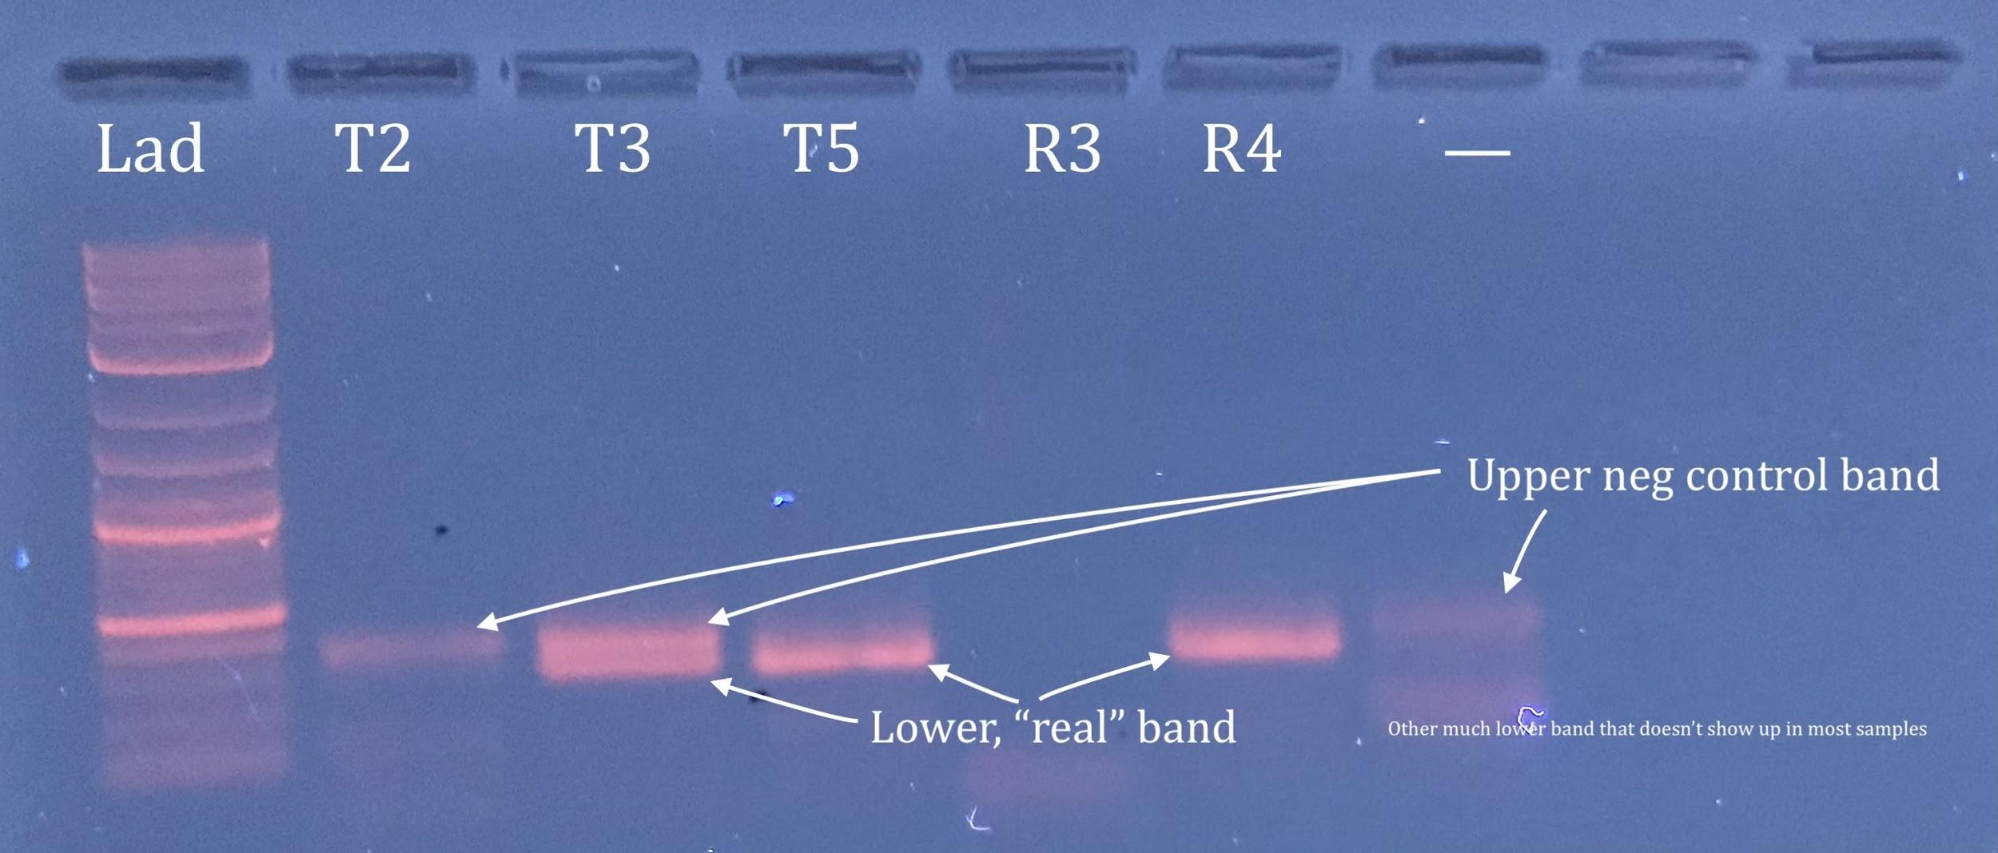

**Barcoding PCR**

**Master Mix Recipe**

Reagent 1x

H2O 11.4µl

10x ExTaq Buffer 2µl

2.5mM dNTPs 1.6µl

ExTaq 0.1µl

Total: 15µl/reaction **plus**

3µl of MiSeq 1µM F & R barcoded adaptors

2µl of 10ng/µl DNA template

**Barcode PCR Profile**

5x 95°C for 40sec

59°C for 2min

72°C for 1min

72°C for 7min

1. Check all samples on gel (can add up to 1-2 more cycles to achieve band)
2. Once all samples run on same gel – “eyeball” product and decide how much to pool into final sample - we start with 5µl per sample and if one lane is 2x less bright, we add 10µl of it to the pooled sample tube, 3µl if too bright, etc.
3. Clean 100µl of pooled samples using GeneJET PCR Purification kit. Elute with 40 µl. (This step is project-specific)
4. Tape 2 wells of 9 well comb together so you can cut out band more easily.
5. Run 20-40µl of pooled sample on 2% agarose gel at 70 V for at least 1.5 hours, until you have sufficient separation between your target band & other non-specific bands. We use SYBR green dye (concentration?) and illuminate on a blue light box so as not to damage DNA with the UV light box. SYBR Green should live in the enzyme box in the lab freezer. Cut out band (target in this case is ~500 bp), soak in 10-20µl milli-Q (or other nuclease free) H2O overnight at +4˚C or use a commercial gel extraction kit
6. Transfer liquid to a fresh tube (you can either throw out or keep the gel part as backup), do P5-P7 test to make sure you have your library ready to go

|  |  |
| --- | --- |
| **Master Mix Recipe**  Reagent 1x  H2O 6.6µl  10x Titaq Buffer 1µl  2.5mM dNTPs 1µl  P5 IC2 10µM 0.2µl  P7 IC1 10µM 0.2µl  TiTaq 0.2µl  Total: 9µl/reaction **plus**  1µl of library | P5-P7 PCR protocol:  12x 95˚C for 5 min  cycles 95°C for 40sec  63°C for 2min  72°C for 1min |

28. Run on 1% agarose gel with gel red (180V for 20 min)

29. If successful amplification, pico green for concentration - protocol for pico green assay is in the Taq Seq protocol document, there is now also a separate document with that protocol in the main folder.

30. Submit for sequencing

**Example Primer Sequences**

It’s fairly simple to create your own barcoded primers. The target amplicon primers are slightly modified to include a linker that any of the remaining barcode primers can bind to. Barcodes can then be used for any amplicon target, so long as amplicon primers are properly modified. Dual barcoding is cost efficient –more samples with less barcodes – ex. 20 forward and 20 reverse barcodes can label up to 400 unique samples. See <https://wikis.utexas.edu/display/GSAF/Illumina+-+all+flavors> for more primer examples and barcodes.

|  |  |  |
| --- | --- | --- |
| **Primer Name** | **Barcode** | Adaptor + Linker + **Pochon ITS2 Forward Primer** |
| ITS2-F-miseq | n/a | TCG TCG GCA GCG TCA GAT GTG TAT AAG AGA CAG **GTGAATTGCAGAACTCCGTG** |
|  |  | Adaptor + Linker + **Pochon ITS2 Forward Primer** |
| ITS2-R-miseq | n/a | GTC TCG TGG GCT CGG AGA TGT GTA TAA GAG ACAG **CCTCCGCTTACTTATATGCTT** |
|  |  | Illumina (Nextera) Primer + Barcode + Forward Adaptor |
| Hyb_F13_i5 | AGTCAA | AAT GAT ACG GCG ACC ACC GAG ATC TAC AC AGTCAA T CGT CGG CAG CGT C |
|  |  | Illumina (Nextera) Primer + Barcode + Reverse Adaptor |
| Hyb_R43_i7 | GCTGTA | CAA GCA GAA GAC GGC ATA CGA GAT GCTGTA GTC TCG TGG GCT CGG |